**To Jacqueline Starr, CEO of the Rail Delivery Group**

We write to you today on behalf of charities in Derbyshire who support people with access needs who will be significantly disadvantaged if the proposed ticket office closures go ahead.

As a group of community organisations, we work with people who regularly face discrimination and disadvantage because of their disability; age; or exclusion from the digital world. For these people, ticket offices provide a fixed point of service where they can seek essential assistance that enables them to travel with dignity and independence.

We are concerned that the proposed plans from the Department for Transport to close ticket offices does not recognise that having a physically permanent point of contact provides safety and service to many disabled users including those with visual, hearing and cognitive impairments.

Additionally, we are not convinced that the proposed alternative arrangements will offer suitable options, especially for those with disabilities or those who cannot use digital tools.

Between April 2022 and March 2023, 168 million journeys involved a ticket office purchase. Many of those who buy their ticket in person have access or communication needs and many have complex enquiries. The ability to have face to face engagement with a member of staff, at a fixed point, is essential for enabling them to travel.

Without ticket offices, rail passengers would be forced to purchase tickets online or using a ticket machine. Both of these options are inaccessible to users with a wide variety of needs and would prevent them from traveling safely on the rail.

In particular, the move towards digital tickets disadvantages the estimated 55,600 Derbyshire residents who do not have access to the internet. Many of whom are older people who have neither the dexterity or digital knowledge to operate mobile apps, websites and ticket machines and will be pushed further towards isolation and loneliness.

We recognise that the Travel Assist option is available but we feel that this not an adequate substitute for the valuable service currently provided by ticket office operators.

**We are petitioning the Rail Delivery Group and those bodies involved in the decision to re-consider the closure of ticket offices.**

**We ask that the rail companies involved produce equality impact assessments that consider the closure of Derbyshire’s ticket offices on all types of passengers across the region.**

**And finally, we ask that you outline and explain how you are going to discharge your duty of care for disabled and elderly users under the Equalities Act and provide reasonable adjustments at Derbyshire stations.**

Signed by:

 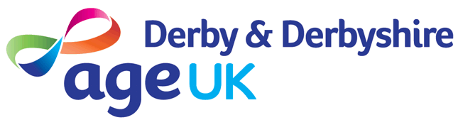

 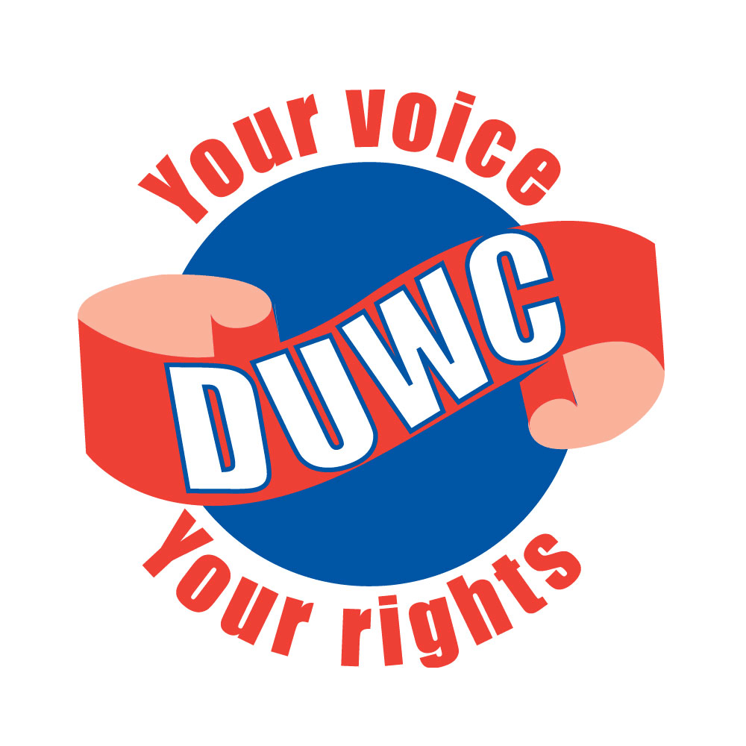 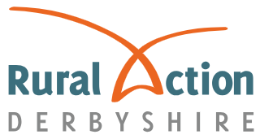

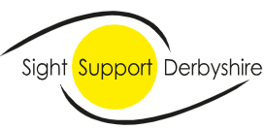  

Careline Calling 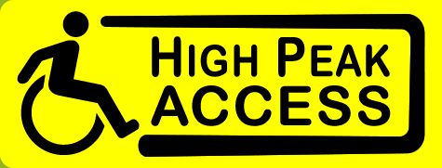 

**Derbyshire Law Centre, BrightLife, Age UK Derbyshire, Good Things Foundation, Home Start Erewash, Rural Action Derbyshire, Sight Support Derbyshire, Deafinitely Women, Derbyshire Unemployed Workers Centre, High Peak Access, Careline Calling**